Comprehensive Guide

Transitioning from WhatsApp to Microsoft Teams

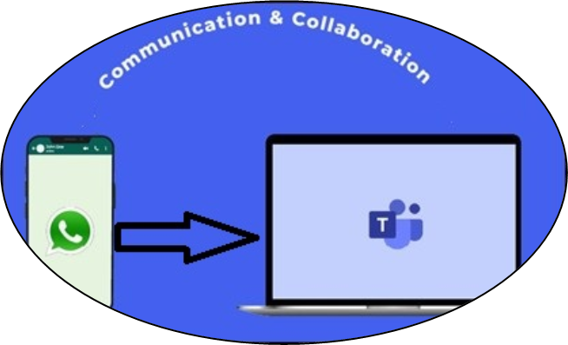

Introduction
This guide will help associates of Piramal Foundation transition from using WhatsApp for work communication to Microsoft Teams. We’ll cover how to set up Teams, use its key features, and map your familiar WhatsApp functions to their Teams equivalents.

Getting Started with Teams

Installation and Setup

Download Microsoft Teams from your play store / app store
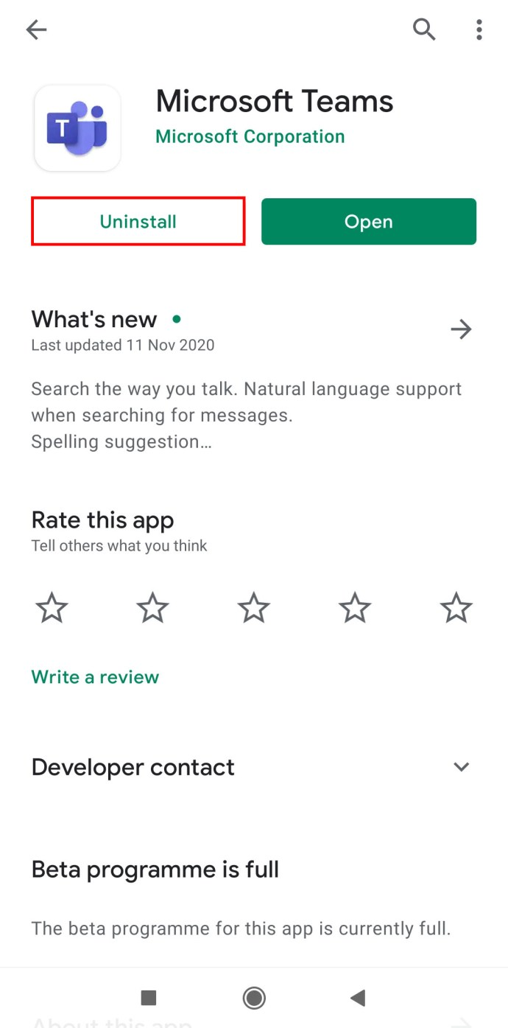

- Sign in with your Piramal Foundation Account
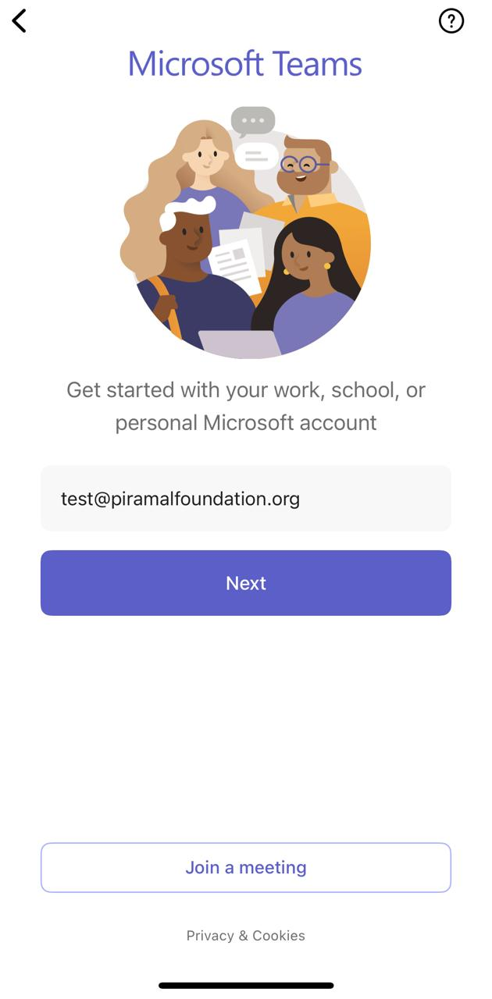

- Set up your profile with a photo and status message (similar to WhatsApp profile)

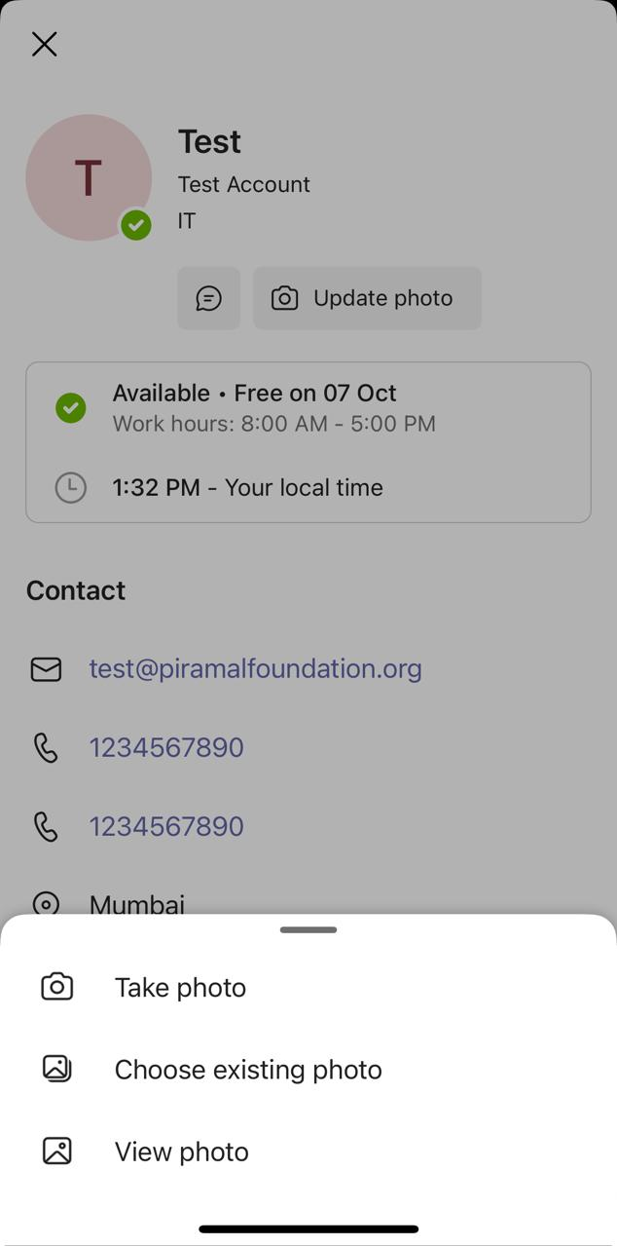
- Enable notifications to stay updated (like WhatsApp notifications)
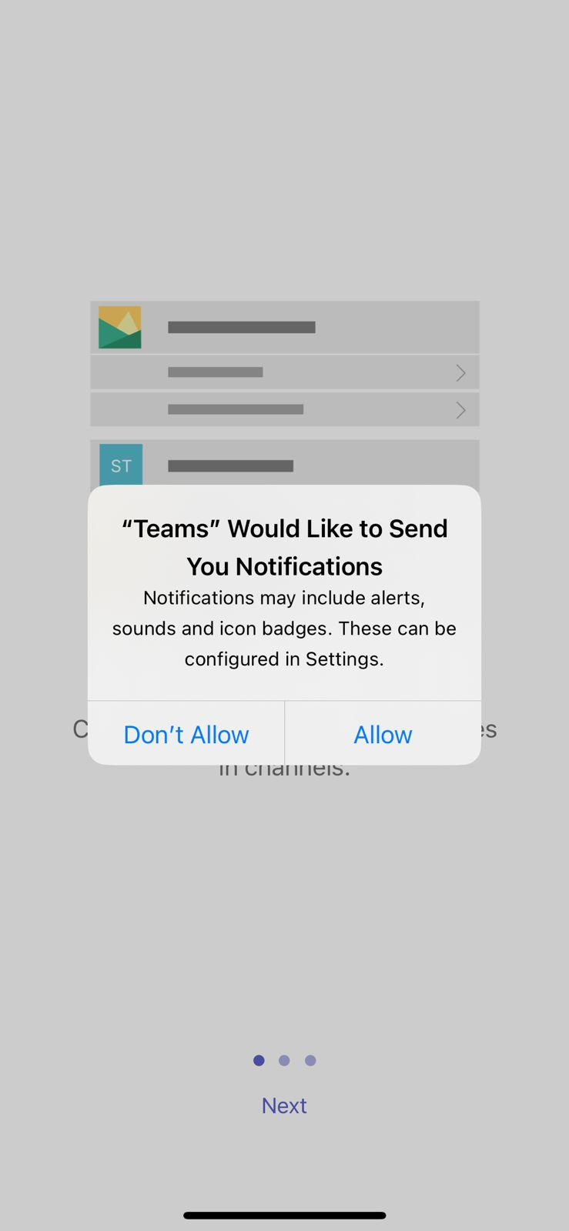

Basic Communication Features

Instant Messaging - One to One chat
- Find contacts in the search bar (like WhatsApp’s search function) –
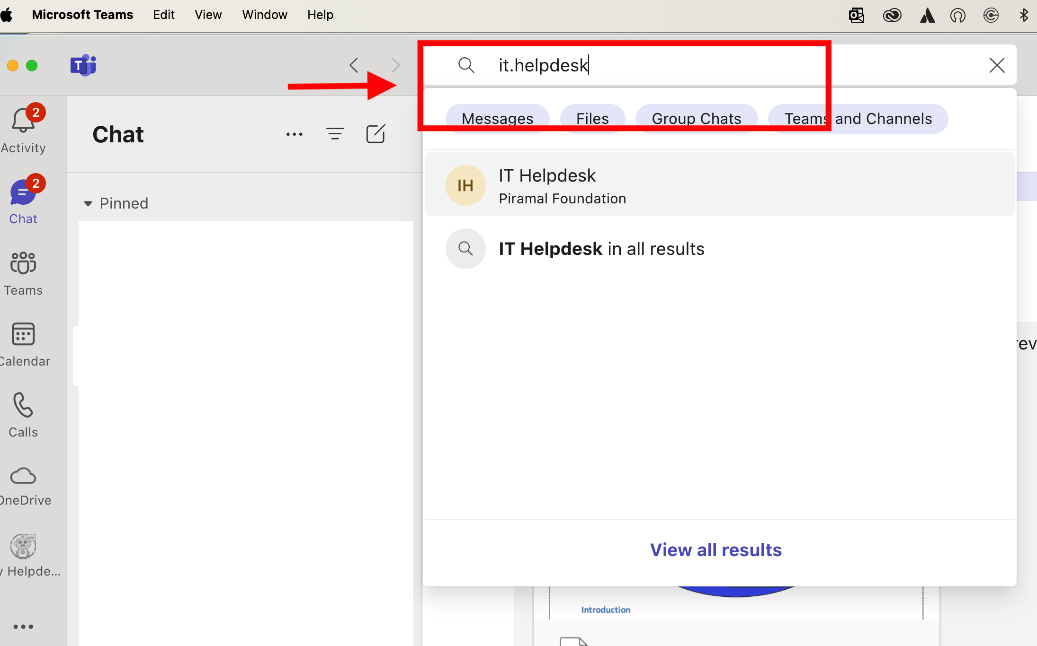

- Start a one-on-one chat by clicking on a contact, Type text and/or attach and Send

Group Communication

- Create a group chat by clicking “New chat” and adding multiple people

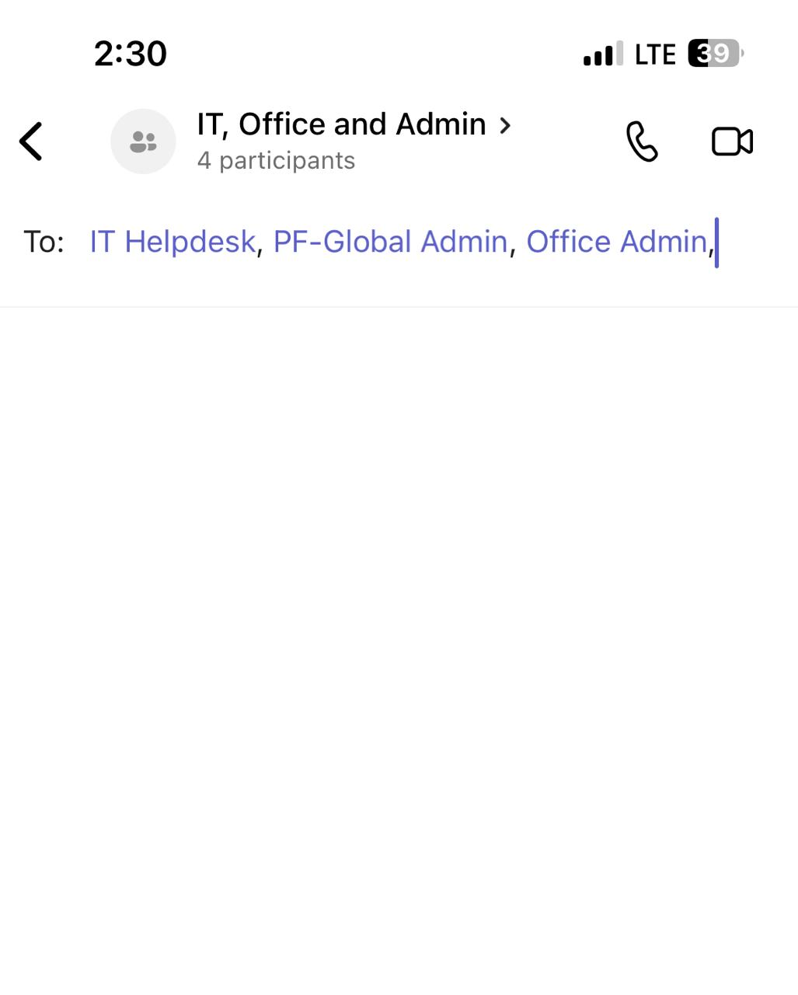
- Name your group chat for easy reference (like naming WhatsApp groups)
- Share files, mention people using @, and use rich formatting

Video and Audio Calls
- Start calls directly from chats or channels (similar to WhatsApp generating video or audio call)

- Use screen sharing and virtual backgrounds (more advanced than WhatsApp)

Teams and Channels (Enhancing Group Communication)
Teams offers a more structured approach with “teams” and “channels” - A team is like a super-group, while channels within a team are like sub-groups

Creating Teams (Equivalent to WhatsApp Groups)
- Click on “Teams” in the left sidebar, then “Join or create a team”
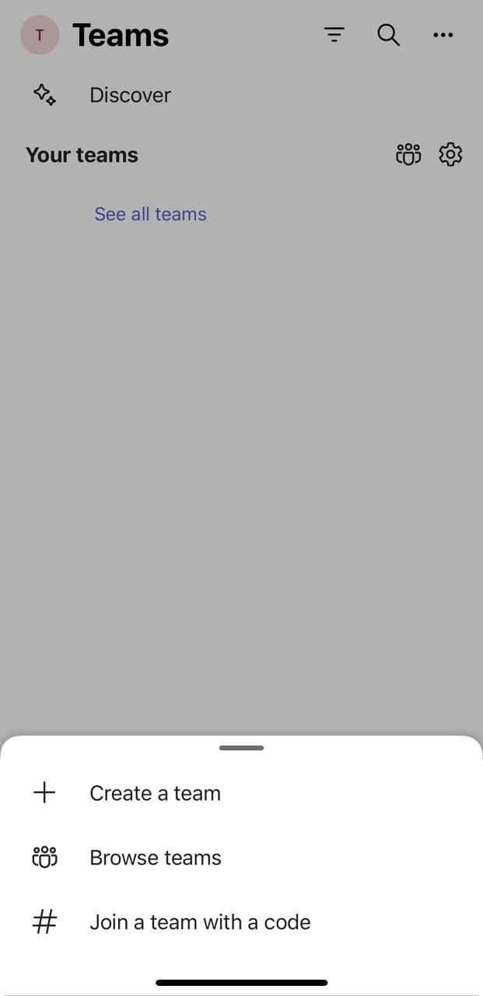
- Choose “Create team” and select the type (e.g., Associate, professional learning community, staff)
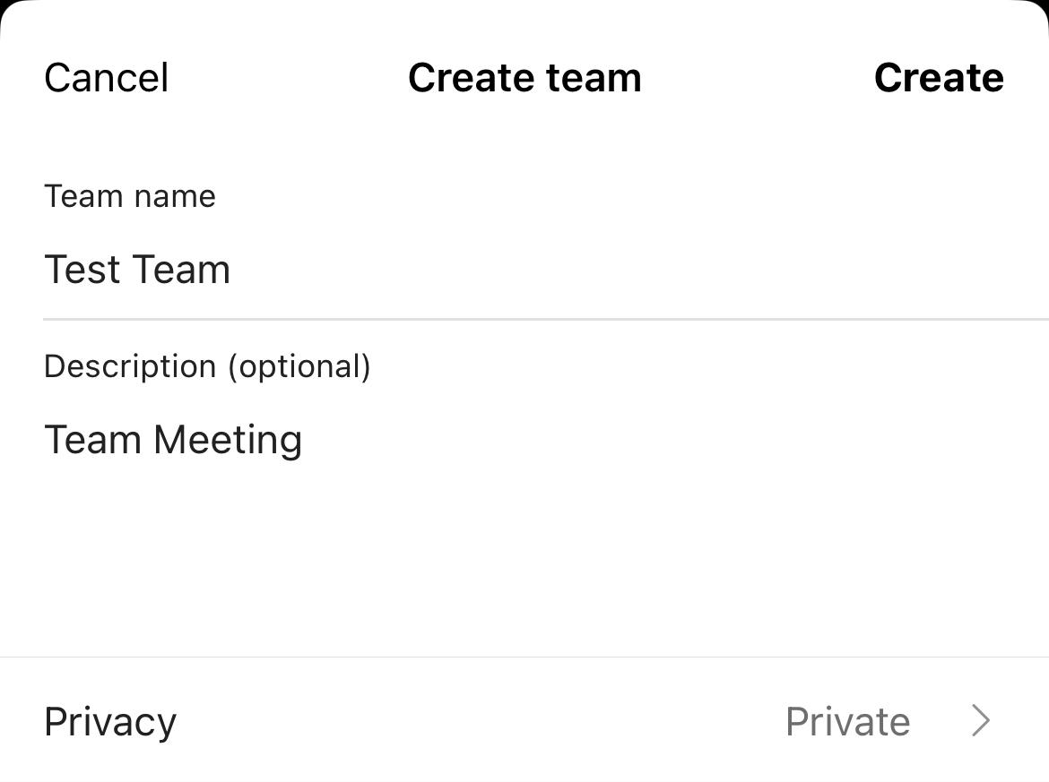

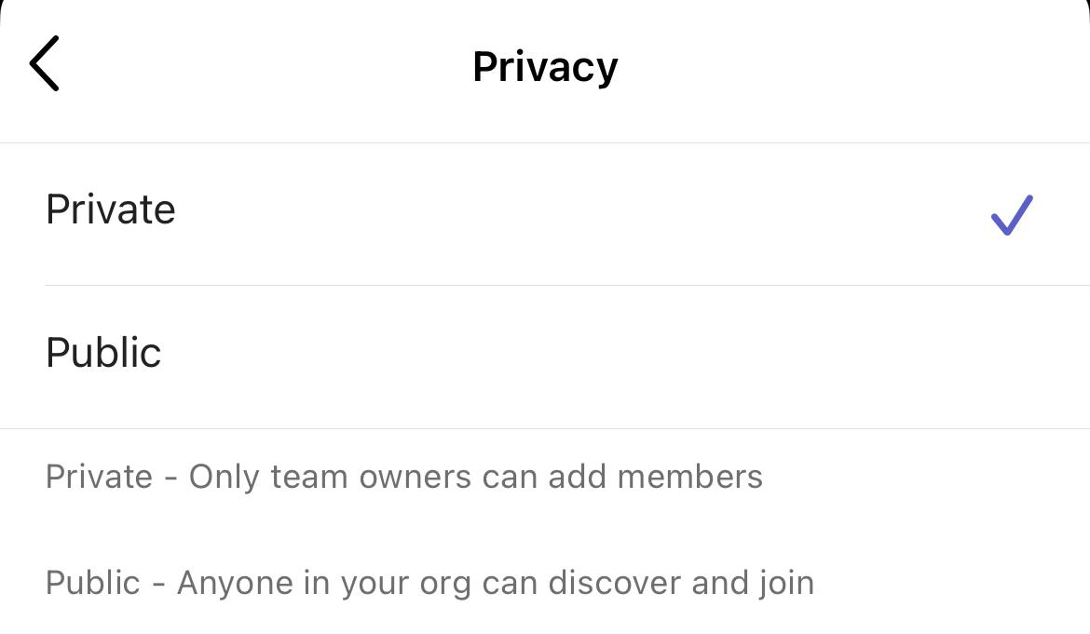

- Name your team (e.g., “IT Department” or “Tech Team”)
- Add members by entering their names or email addresses
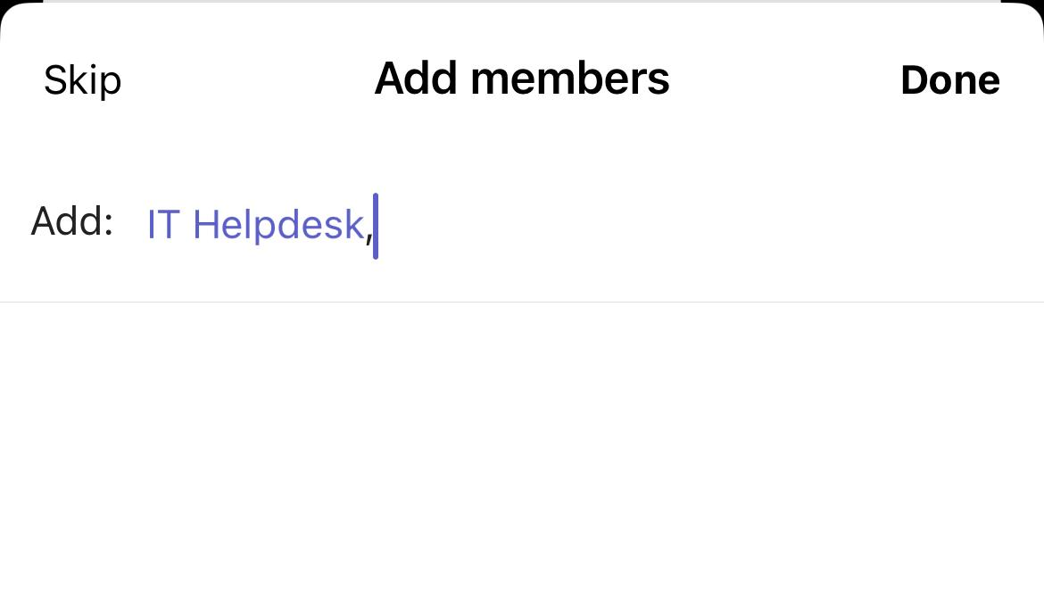

Setting Up Channels (For Focused Discussions)
- In your team, click “More options” (…) next to the team name
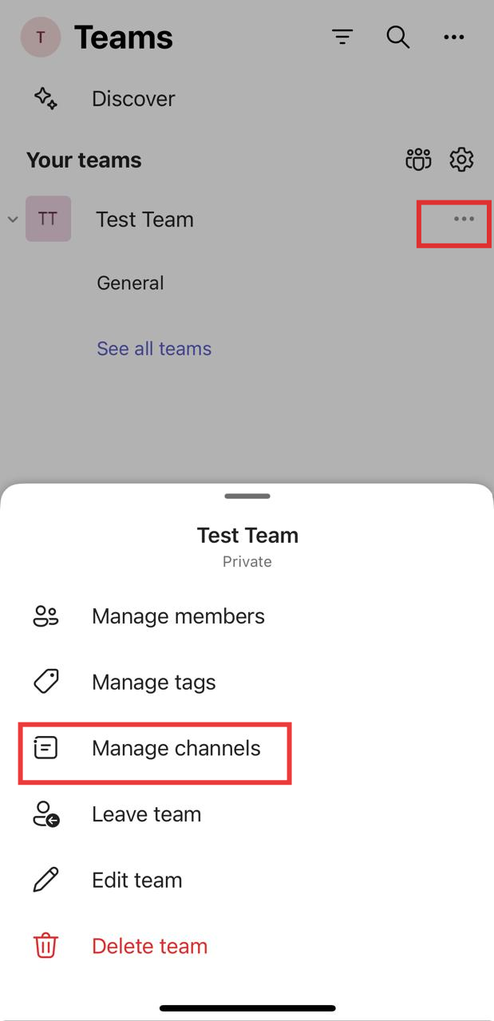

- Select “Add channel”
- Name your channel (e.g., “Campaign Ideas”, “Budget Discussions”)
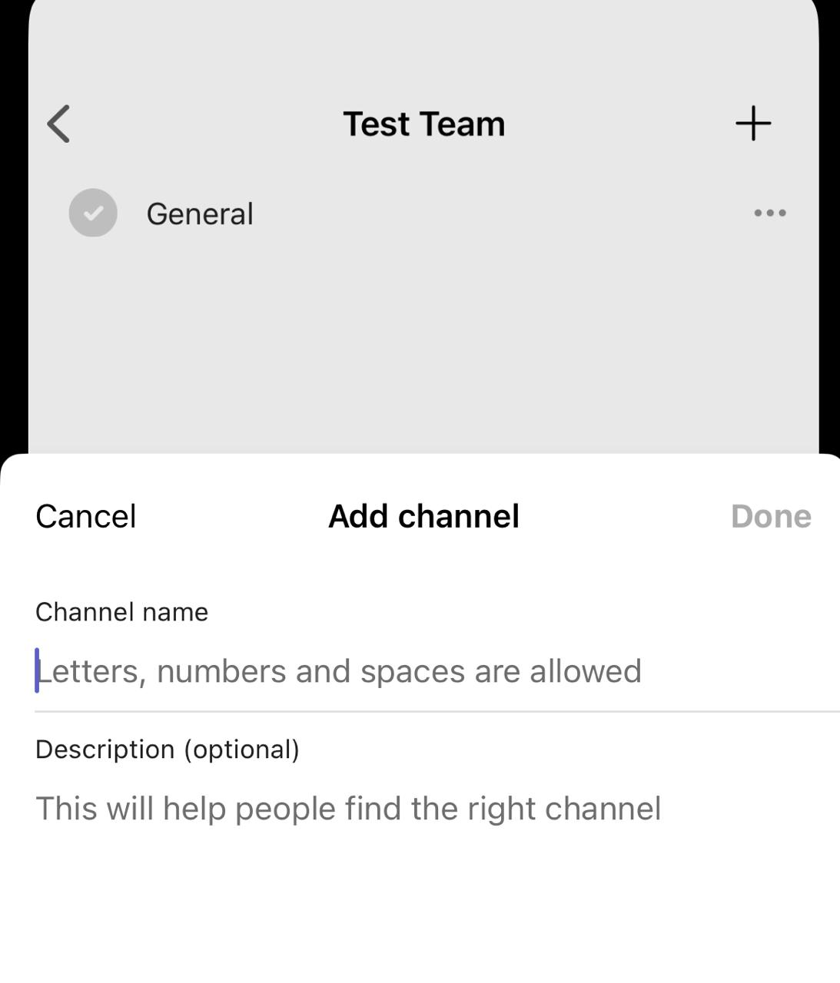

- Set privacy settings (Standard = visible to all team members, Private = select members only)
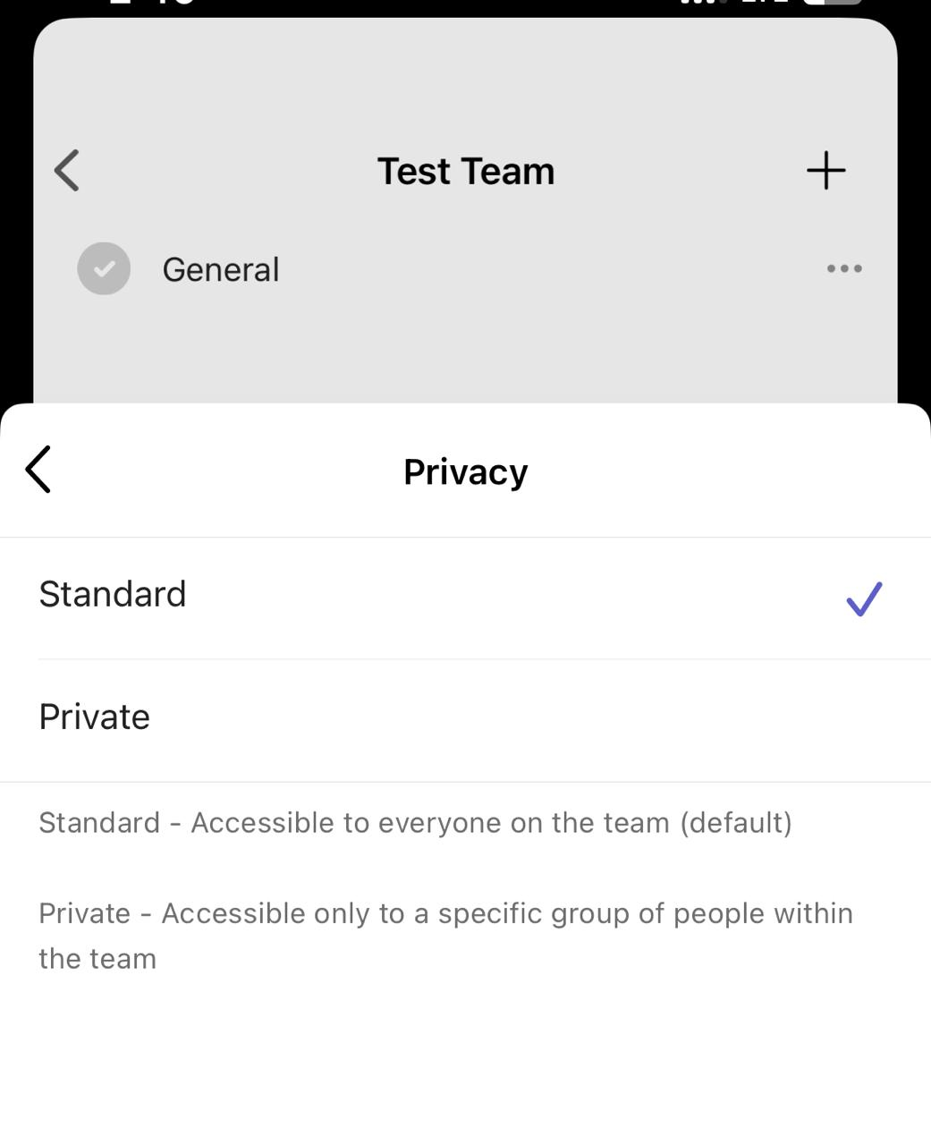

Advanced Features and Benefits

Key Advantages Over WhatsApp
- Designed for work communication with more robust features
- Better file sharing and collaboration tools (edit documents directly in Teams)
- Integration with other Microsoft 365 apps (replaces the need for separate work tools)
- More structured communication with channels and teams (vs. WhatsApp’s simpler group structure)

Enhanced Collaboration in Channels
- Pin important messages and files for easy access
- Use tabs in channels to embed frequently used files, apps, or websites
- Set up connectors to receive updates from other services (e.g., Twitter, RSS feeds)
- Use bots for automated tasks and quick information retrieval

Deleting and archiving Teams and Channels

Deleting Teams and Channels
The process is more nuanced due to the collaborative nature of Teams and the amount of data that can be associated with a team or channel.

Deleting a Channel
- Navigate to the team containing the channel you want to delete
- Click the "..." (More options) next to the channel name
- Select "Delete this channel"
- Confirm your decision in the pop-up window
*Screenshots of each step

Note:
- The General channel cannot be deleted
- Deleted channels can be restored within 21 days by team owners

Deleting a Team
- Click the "..." (More options) next to the team name
- Select "Delete the team"
- Confirm your decision in the pop-up window

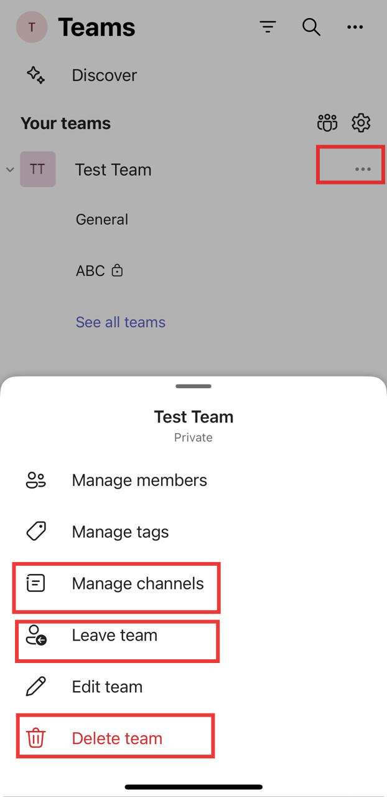
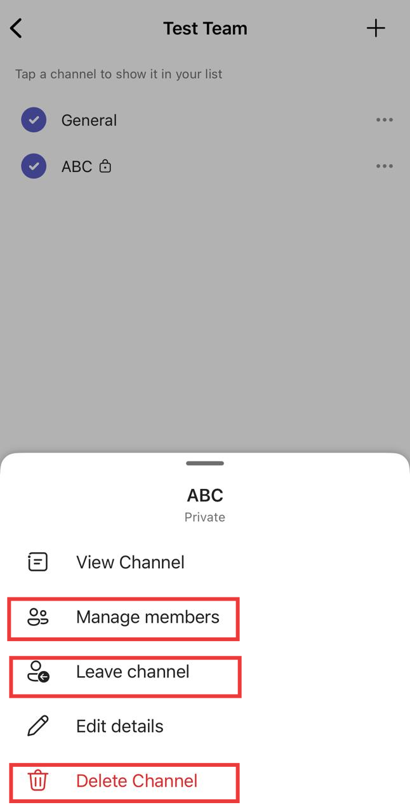

Important considerations:
- Only team owners can delete a team
- Deleting a team removes all associated channels, files, and conversations
- This action is irreversible after 30 days
- Consider archiving instead of deleting if you might need the information later

Archiving vs. Deleting
- Archiving a team makes it read-only and hides it from active teams
- Archived teams can be reactivated later if needed
- To archive: Click "..." next to the team name, then "Archive team"

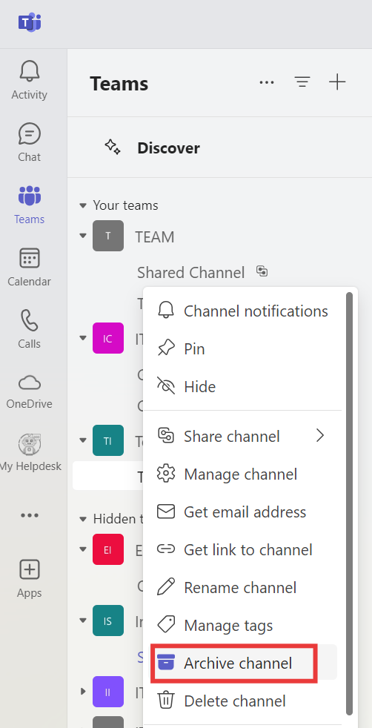

Best Practices for Team/Channel Management
- Regularly review your teams and channels for relevance
- Archive completed projects rather than deleting them immediately
- Clearly communicate to team members before deleting a team or channel
- Export important data before deletion if you need to retain records
- Use naming conventions to easily identify outdated teams/channels

Tips for a Smooth Transition from WhatsApp to Teams
- Create teams and channels that mirror your WhatsApp groups
- Use the chat feature in Teams for quick, informal conversations (like how you use WhatsApp)
- Create a team structure that mirrors your existing WhatsApp groups if you wish to.
- Use the General channel for announcements and organizational-wide discussions
- Encourage members to use threaded conversations in channels for better organization of conversation
- Utilize the Wiki tab in each channel for shared notetaking and documentation
- Mapping WhatsApp Groups to Teams
  - Large, department-wide WhatsApp groups → Create a Team
  - Topic-specific chats within a group → Create Channels within that Team
    - Example:
      - WhatsApp “Tech Team” group → “Tech Team” Team in Teams
      - Ongoing chats about “Developers” in that WhatsApp group → “Developers” Channel in the Tech Team
Remember to follow Piramal Foundation’s Data privacy and Information security guidelines for using Teams and sharing information. Teams offers more control over data and compliance features compared to WhatsApp, which is beneficial for work environment.

New Section 7 :

- Create a New Team: Click on Peoples Icon in Teams

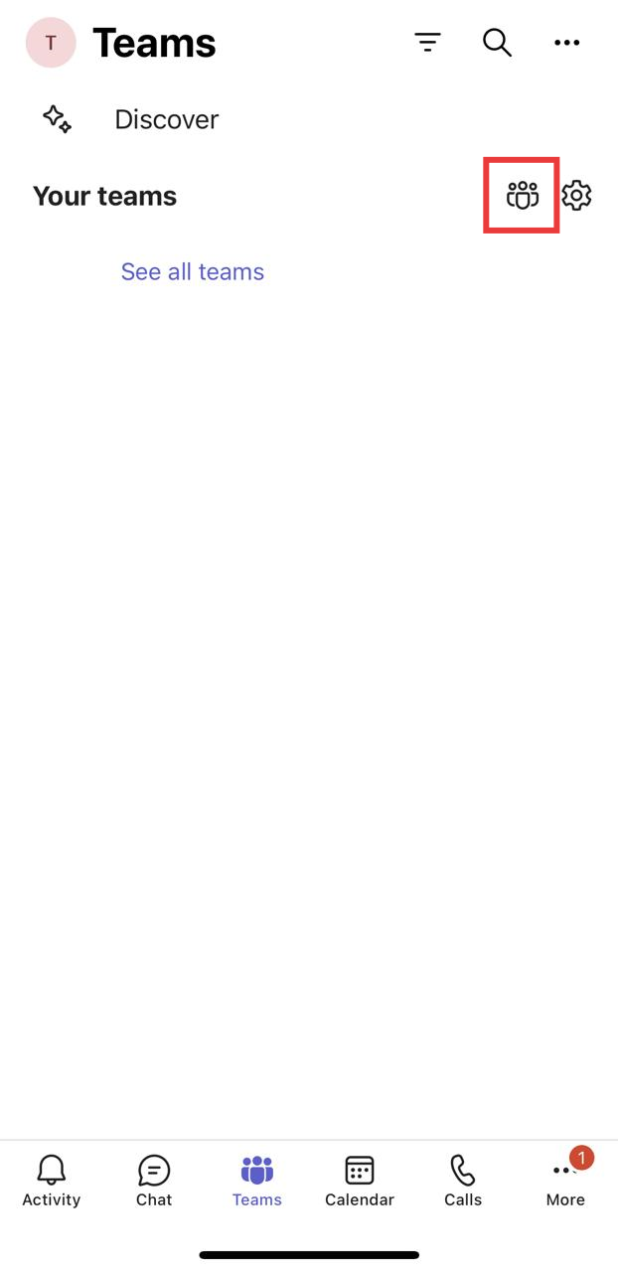

- Create a Team:

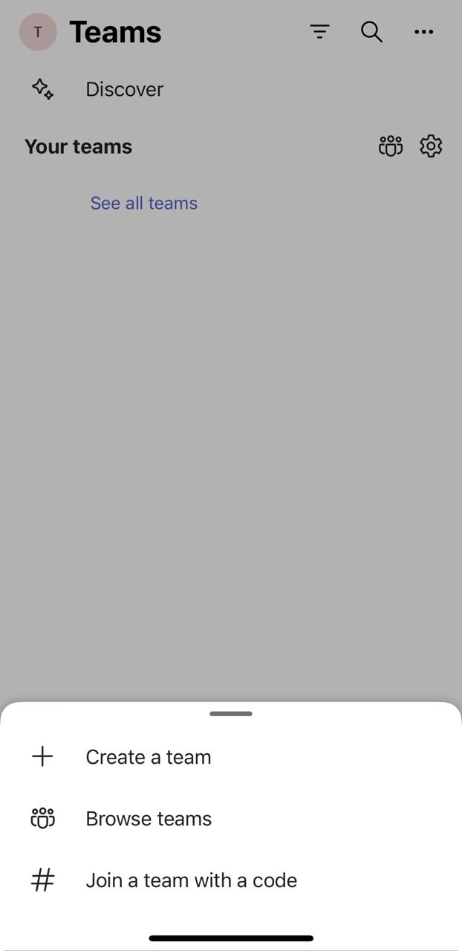

3. Provide Team Name & Description:


4. Click in Manage Channels

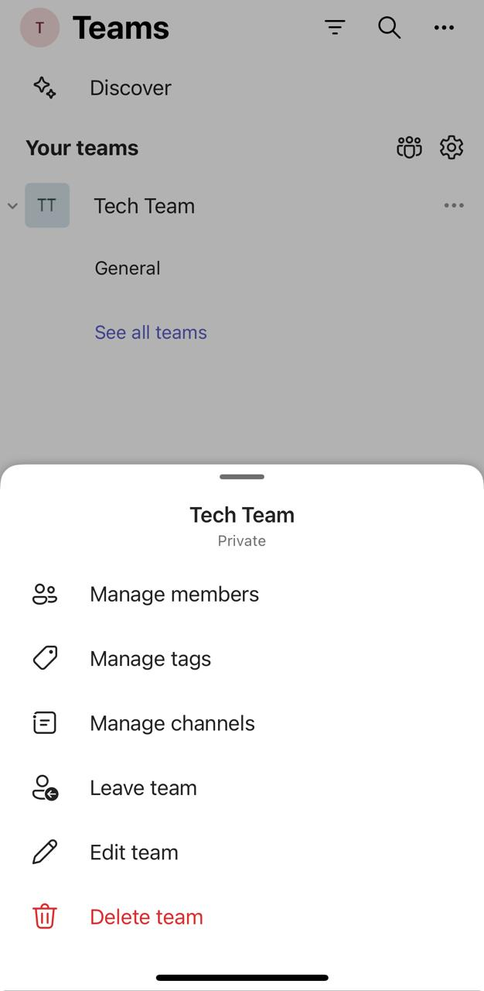

5. Provide Channel Name & Description:

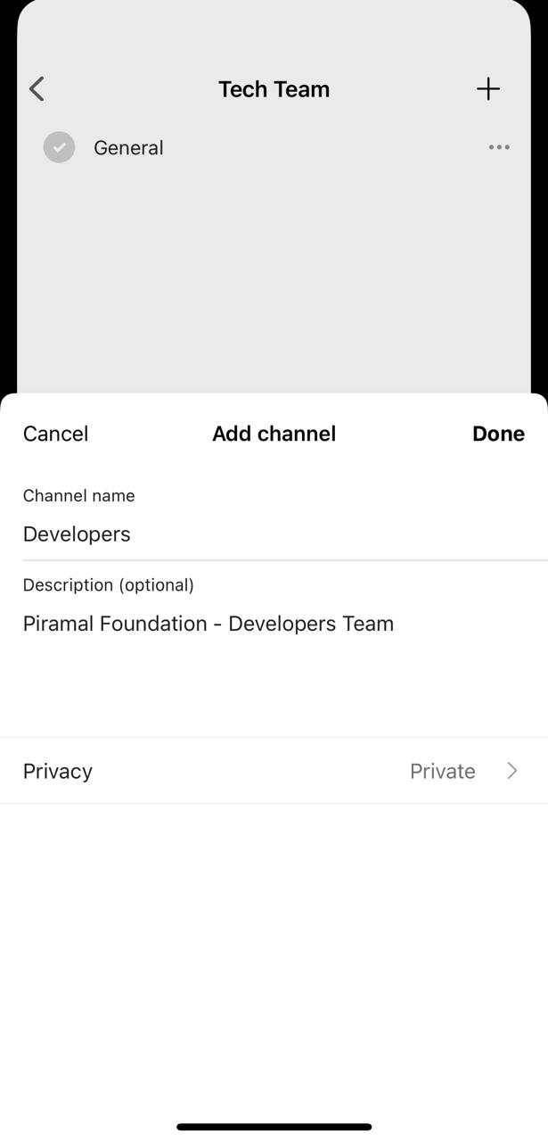

6. Click on Channel Name for more settings.
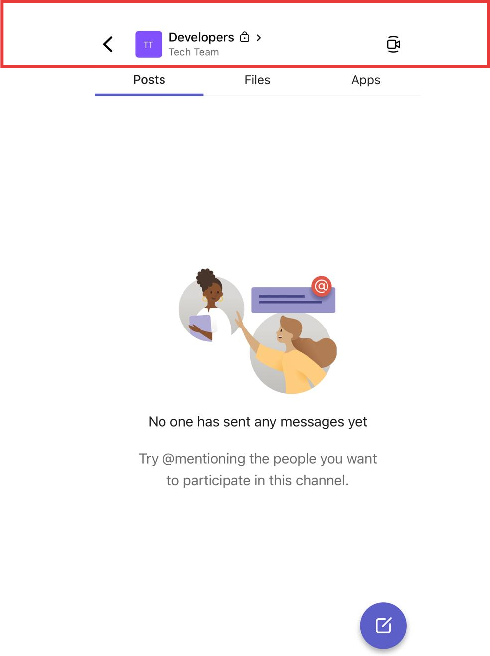

- You can pin the channel & enable notifications

